DATE:

2019-11-18

EXPERIMENT NAME AND DESCRIPTION

Internal Standards Experiment:

In order to check matrix effect and equipment response to distinct concentrations of IS (4 in-house compounds + Amino Acid MIX), an experiment with QC samples spiked with different concentrations was planned as follows

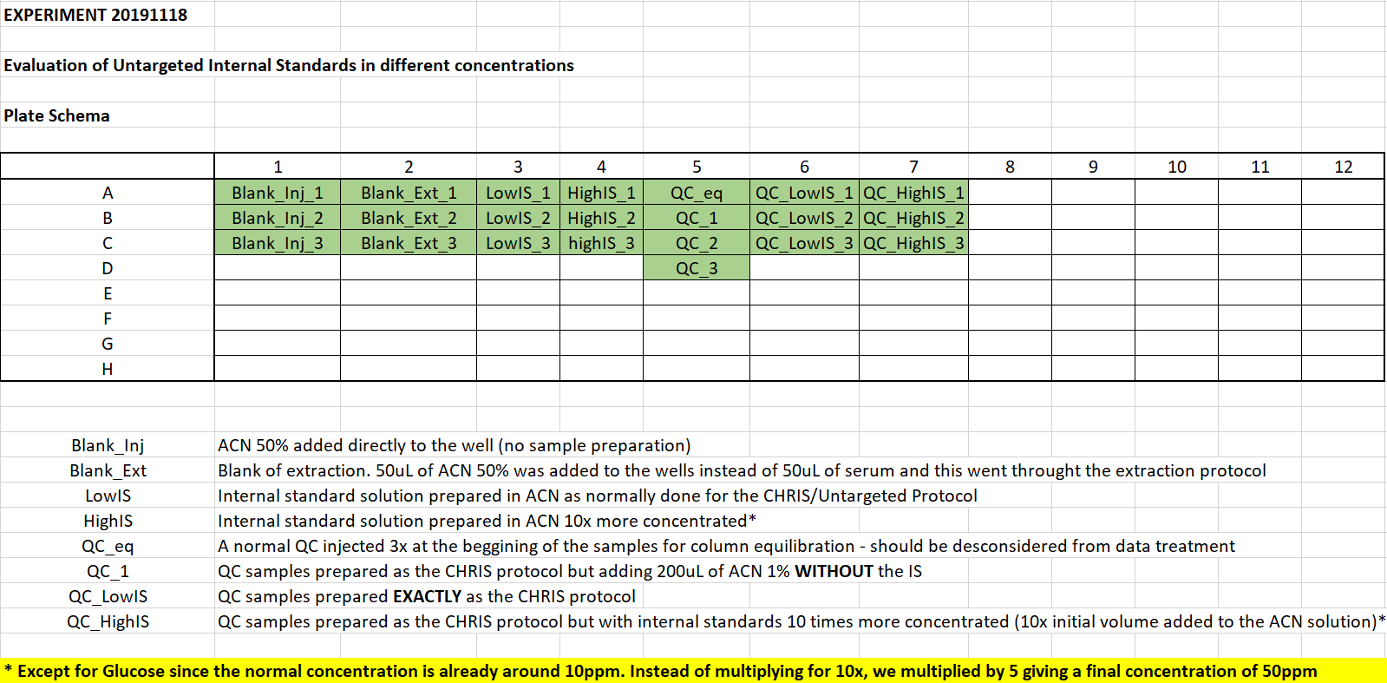

SAMPLE PREPARATION

See protocol here:

J:\Lab Operations\MassSpec\UNTARGETED_method.docx

EQUIPMENT PREPARATION

* Source was cleaned
* Mobile phases were replaced by new ones (Method: SHORT_AMIDE_POS)
* New pre-column installed (column already used before for around 150 samples)
* CDS calibration was performed before AND during analysis (see worklist)

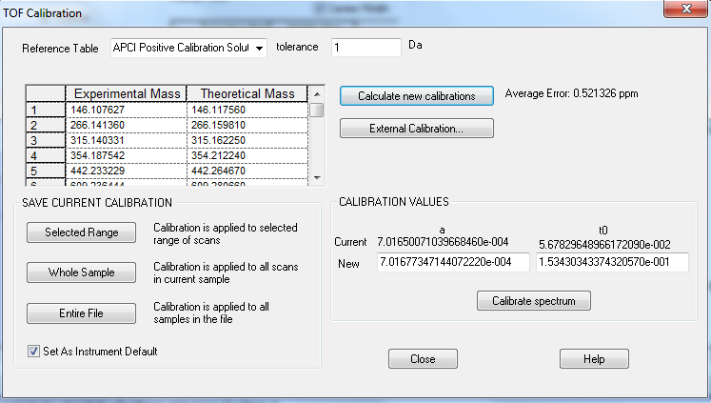

INJECTION LIST

